Mission 10 Assignment Log | Name:
Pre-Mission Preparation
In previous missions you used an object sensor and a motion sensor. Both are digital input devices and can detect the presence of something, but they don’t give any details. For this mission you want to if there is an object AND how far away it is. What are some examples of when knowing the distance is essential?
Mission 10 Checks
Objective #1
What are the parts you will use for this mission?

Objective #2  Label the missing parts of the diagram: | 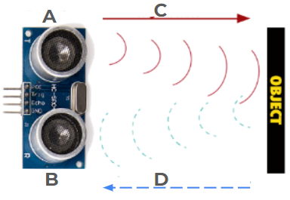
Objective #3  What time measurement is used by the ultrasonic sensor?  What formula is used to calculate the distance?  Create a chart when running code to check the accuracy of the ultrasonic sensor. | Object Actual Distance Ultrasonic Sensor Reading
Objective #4
What programming technique is used to stop the loop if no object is detected?

What is returned if no object is detected?
Objective #5
Why do you need to use resistors with LEDs?

Objective #6  On the LED: The long end is ______ and is connected to the _________. The short end is ________ and is connected to the __________. | Long end  Connected to  Short end  Connected to
Objective #7
After typing in the code and running it, what do you notice about the alarm system? Does it work the way you expect it to?
Objective #8
What code did you add during this objective?

Objective #9
What code did you add during this objective?

Objective #10
What code did you add during this objective?

Post-Mission Reflection
Warning systems are very common in real-world applications. What warning systems do you see or use? What data do they use for the warning?

